One day I was on my way to foten and i found a squirrel hit by a car, I took and removed it from the road with two sheets of paper, I buried it at the side of the road. There were several squirrels there.

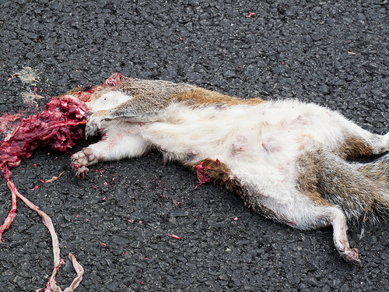

**Poor little squirrel! You are å good boy, Simon!**

Today I drove to a place called “Gamlebyen” And we went to the baker and bought a bun with coco and apple on it.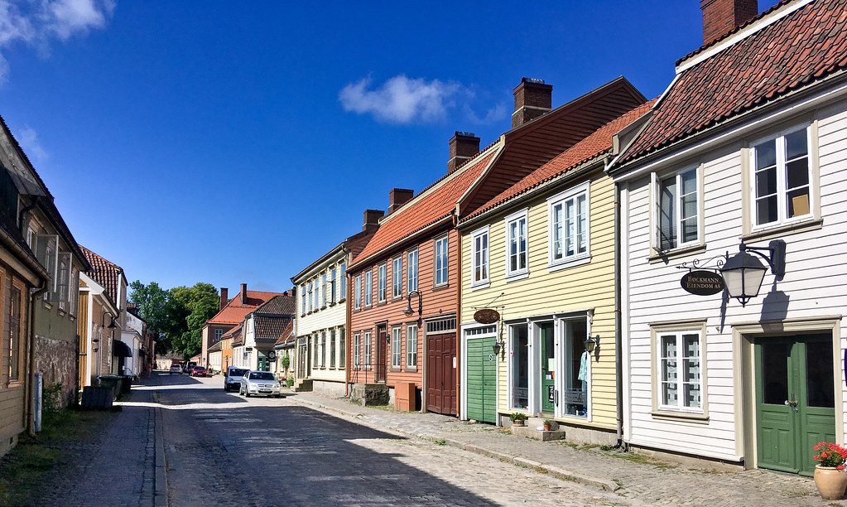

**“School-bread” from Old Town Baking Company is delicious!**

**I would like to know more about your blog, Simon!** 😊